Low Level Design (fundtransfer module)

Project Code | Team7
Project Name | OnlineBankingSystem

Prepared/Modified by | Role | Date of Preparation
Vishesh,Vaibhav,Harshit,Kavitha | Team Members | 15/11/2017
Reviewed by | Role | Date of Review
Approved by | Role | Date of Approval
Circulation List |  | Version Number of the template:1.0
Version Number

Table of Contents

1. Description Of The Unit 3
2. References 4
3. Dependencies / Assumptions 5
4. Class Diagrams 6
5. Sequence Diagrams 7
6. Design Components 8
6.1 List Of UI Components 8
6.2 List Of Design Classes 8
7. Re-Usable Routines/Components 9
8. Messages 10
9. Configuration Files 11
10. Crud Matrix Table 12
11. Data Mapping Matrix 13
12. Action Flow Matrix 14
13. Stored Procedures 15
REVISION HISTORY OF THE WORK PRODUCT 17

Description Of The Unit

The Fund Transfer module is basically used by the customer to transfer money from his account to payee’s account. It requires a pre-requisite that the customer should be logged into the system.
On clicking the Fund Transfer button on the home page, the customer will be navigated to the Fund Transfer page where he can transfer the money. In this page user is asked to enter details like account Id, payee’s Account Id, transfer Amount, Description and Nickname for payee. If the details entered by the user is valid then on clicking Transfer amount button, amount is transferred to the payee’s account.

References

Reference | Description
Repository reference | https://github.com/VISH9415/PLP-OBS
Class Diagram | /Project Documents/Design Documents/HLD/Class Diagrams
URS | /Project Documents/Requirements/Case Study/
UTP | /Project Documents/Test Plan /UTP /Test Cases/
DB Design | /Project Documents/Design Documents/HLD/DB Design/OnlineBankingSystem_GROUP_DBDESIGN.xls

Dependencies / Assumptions

Dependencies:
Fund Transfer module depends on the Login module in such a way that, the customer is able to transfer amount only when he is logged in.
If the customer is not logged in then he/she will be asked to login.

Assumptions:
Customer details are stored in a database.

Class Diagrams

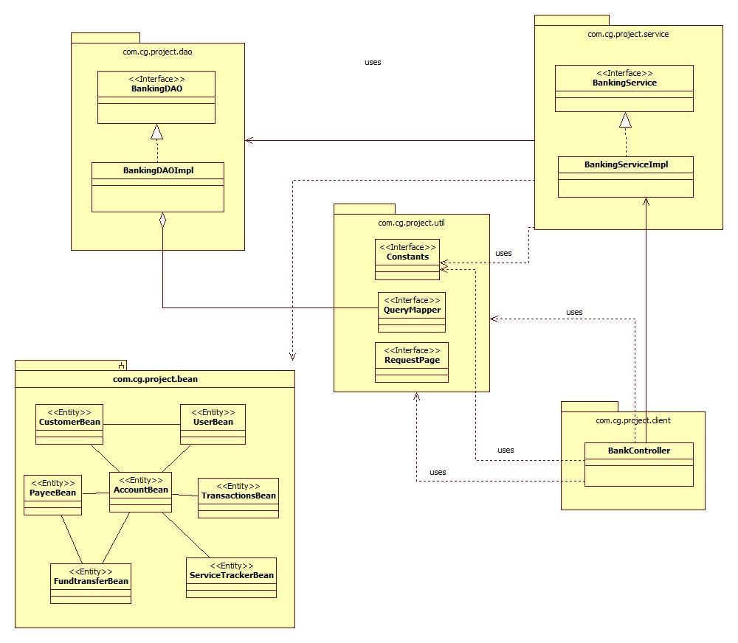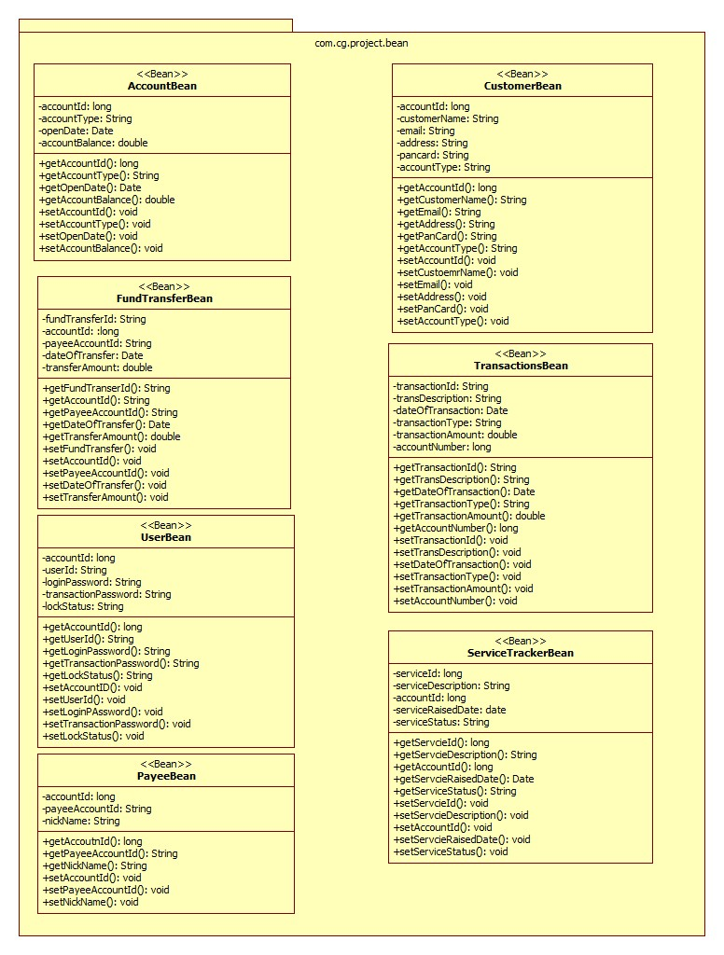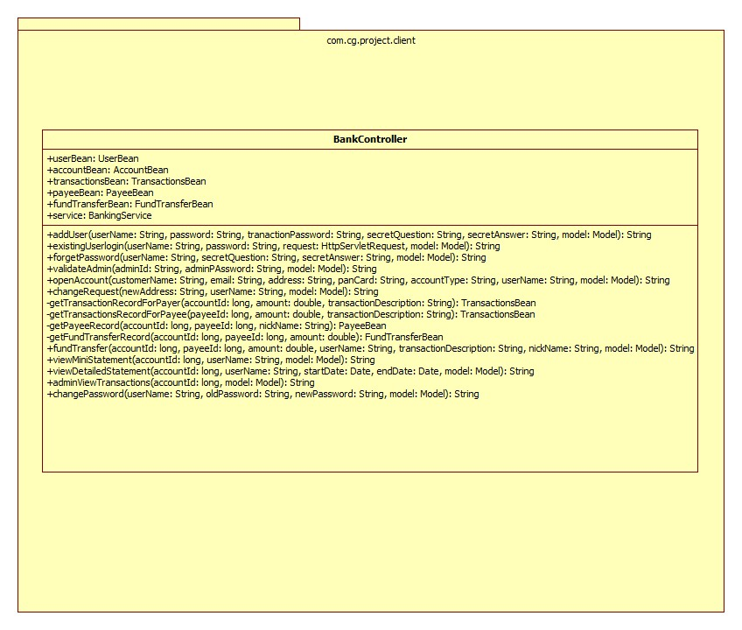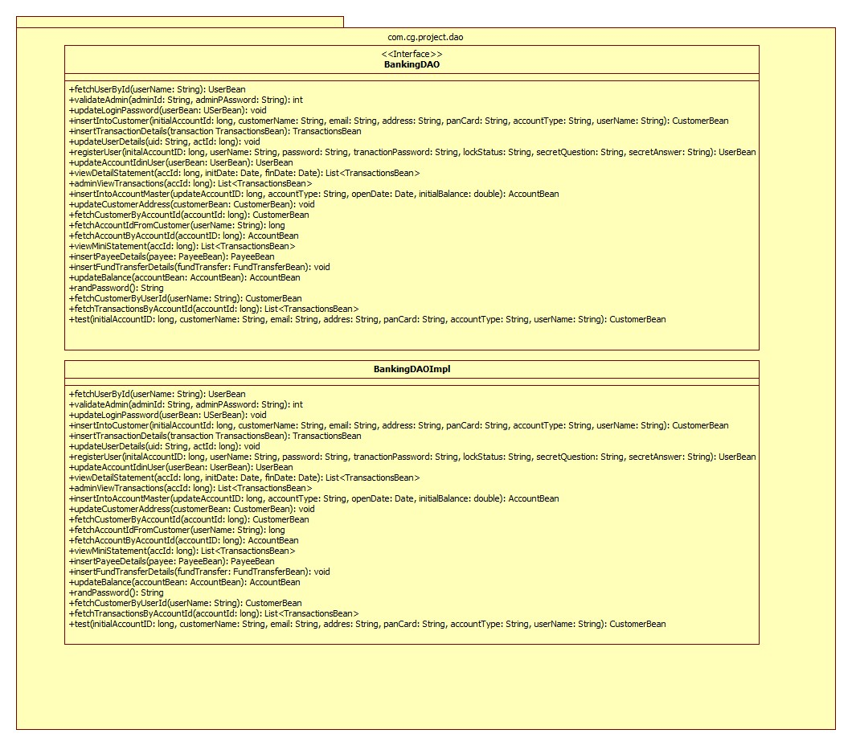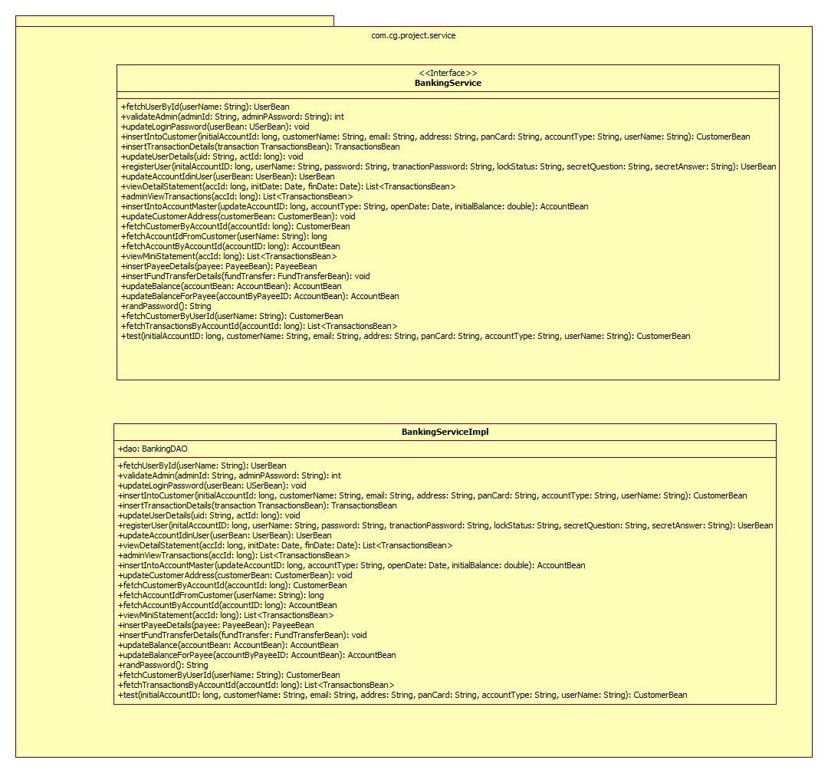

Sequence Diagrams

Sequence Diagram
NA

Design Components

List Of UI Components

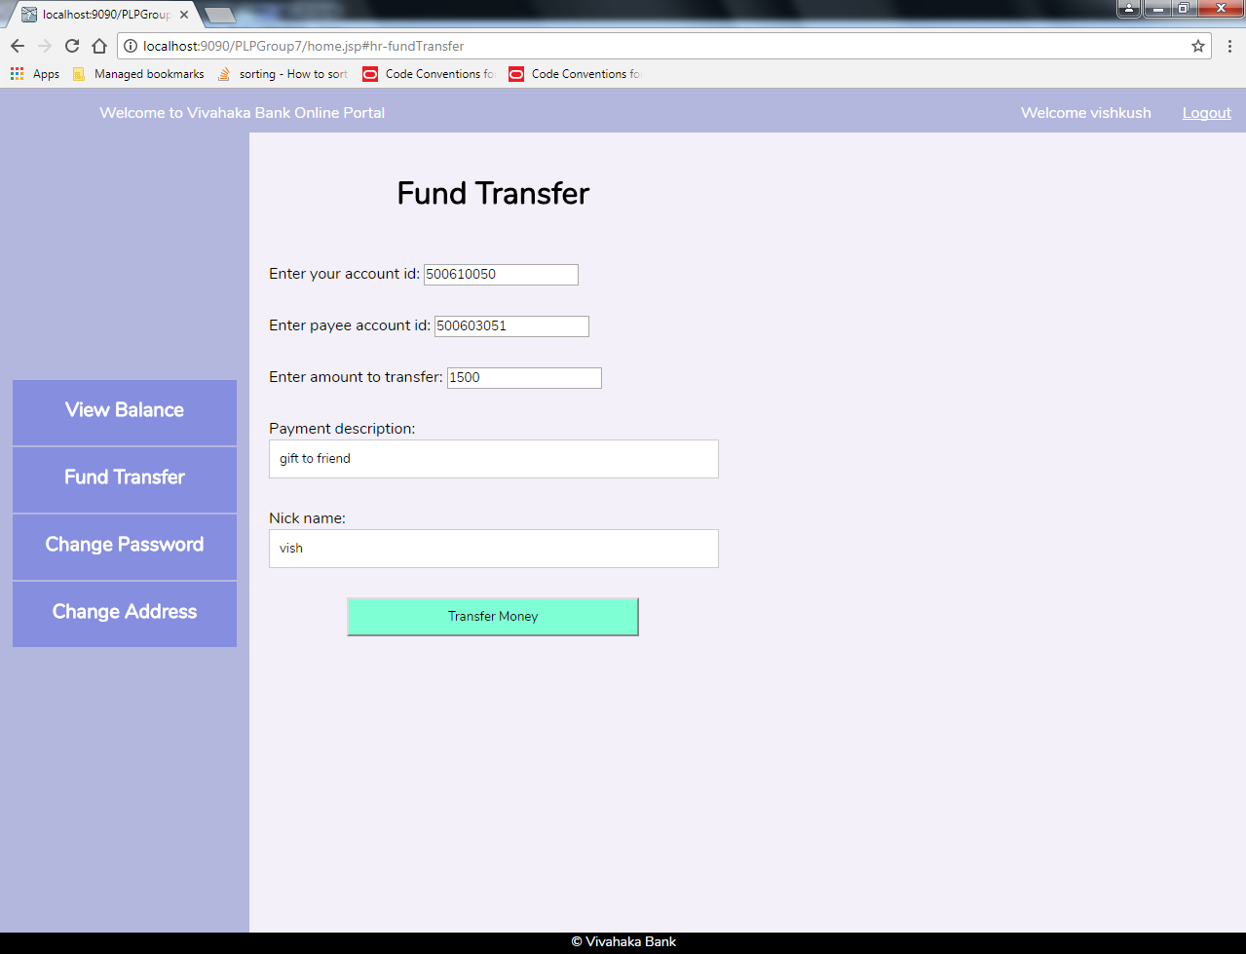
Fig: Fund Transfer request Form

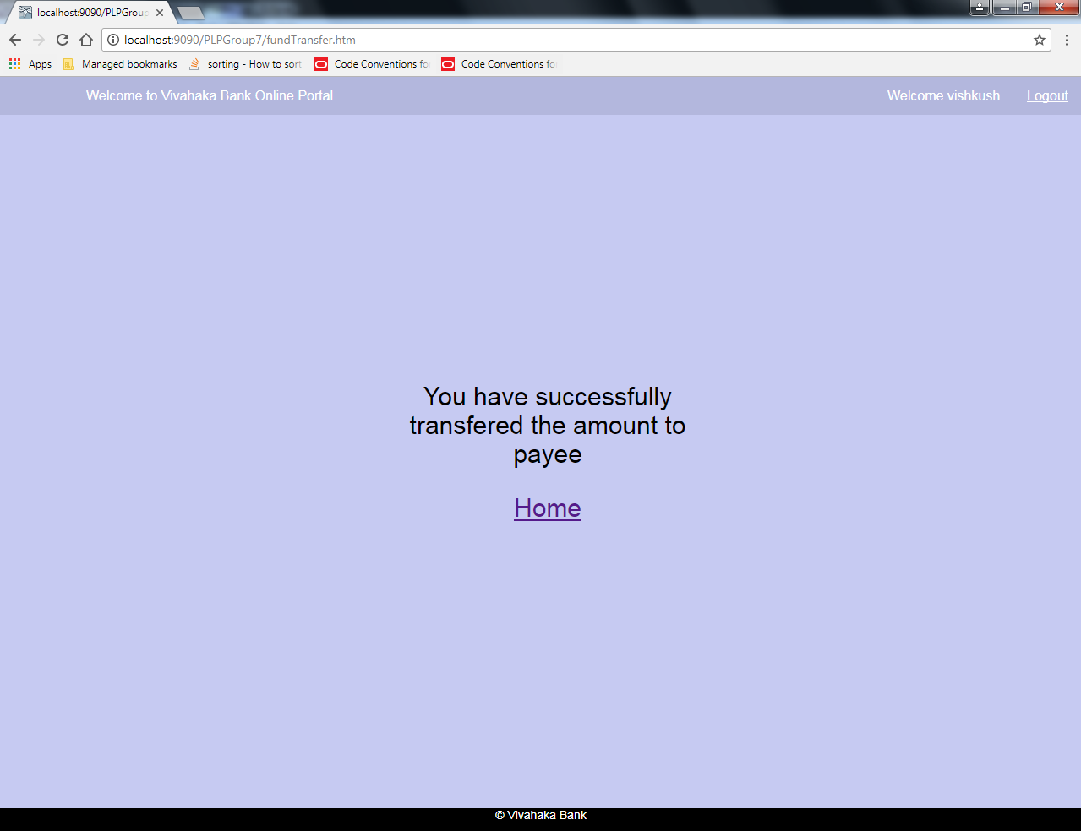

Fig: Successful Fund Transfer

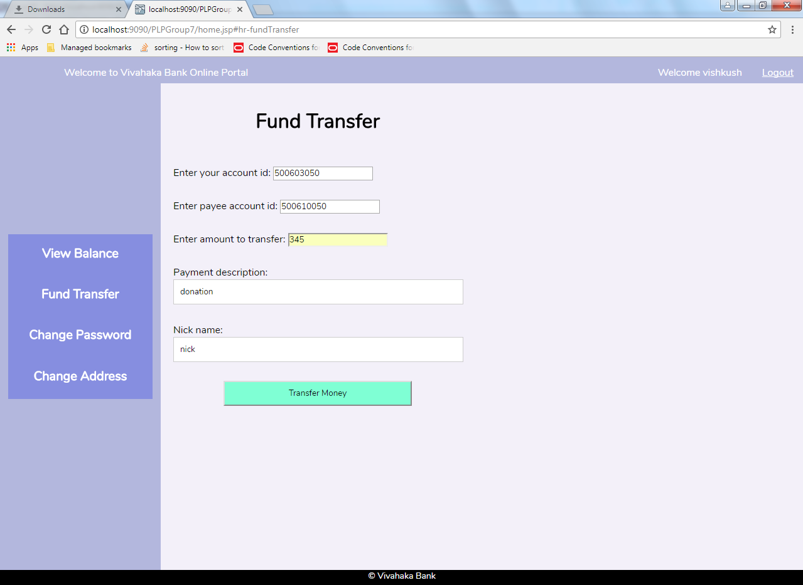

Fig: Incorrect account Id for payer while transferring funds
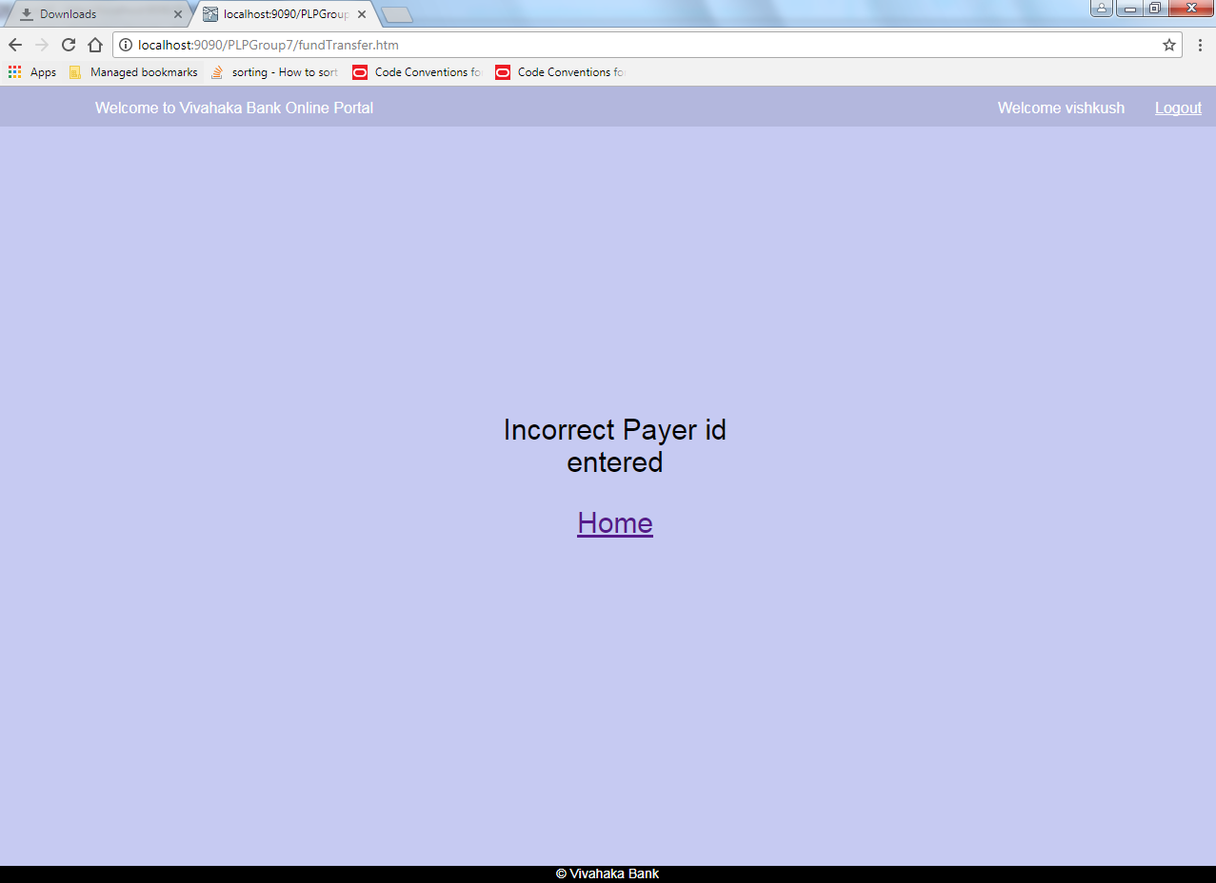
Fig: FundTransfer failed
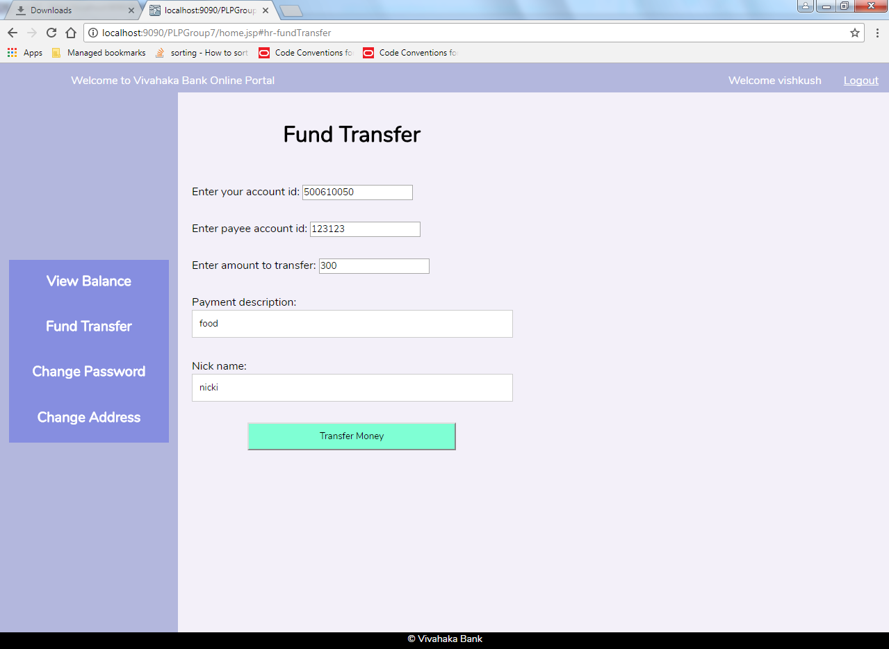
Fig: Incorrect account Id for payee while transferring funds

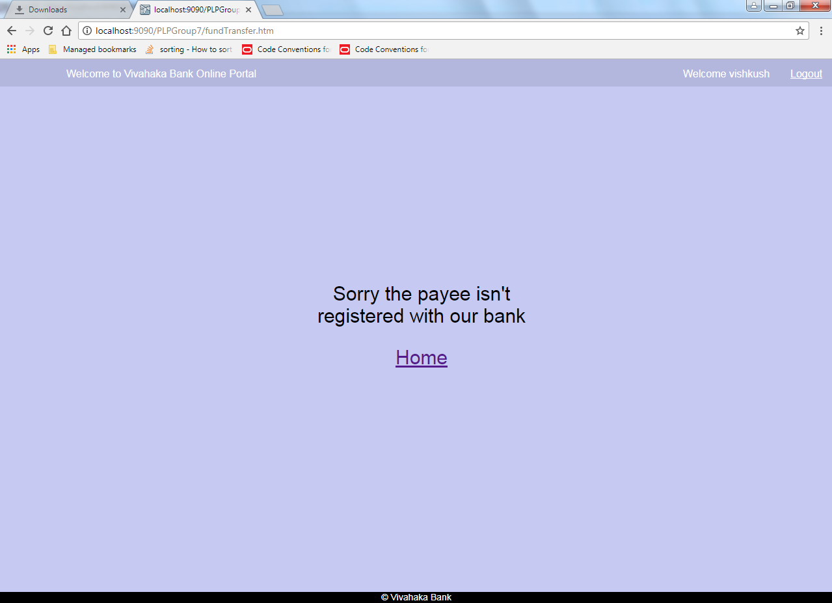
Fig: Fund Transfer failed.

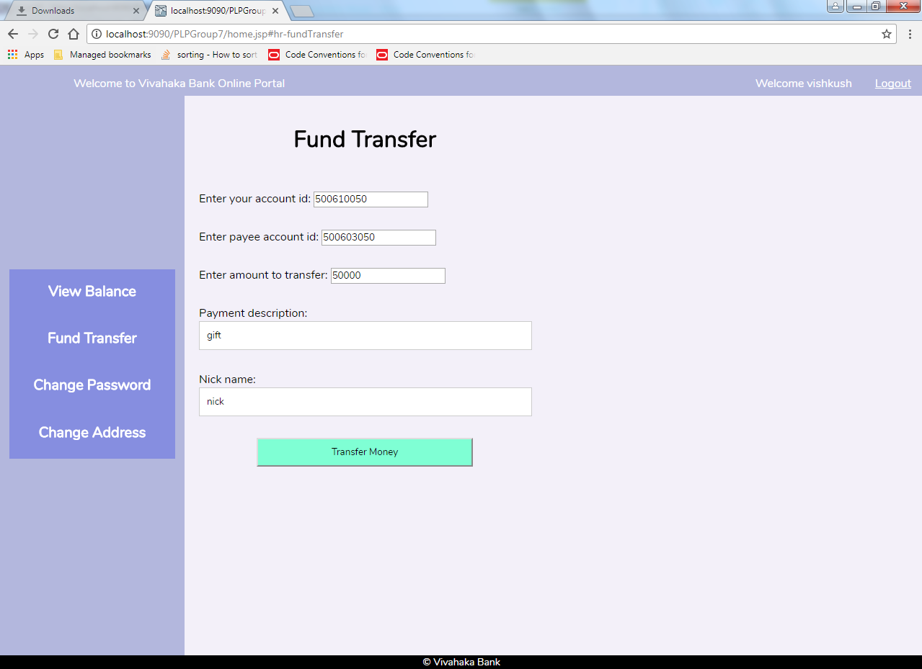
Fig: Fund Transfer request with invalid amount

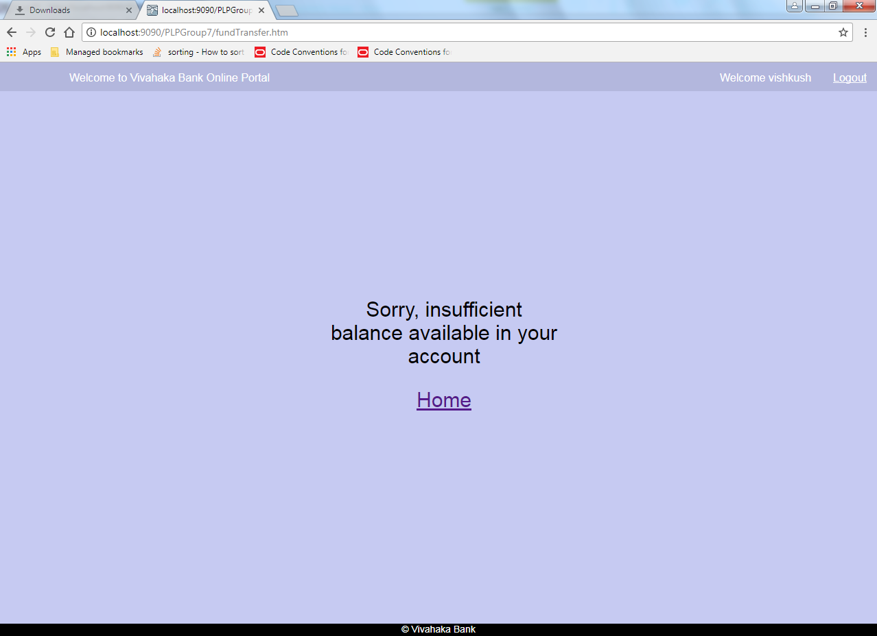
Fig: Fund Transfer failed.

List Of Design Classes

Sr. No. | LLD Name | Class Name | Method Name | Method Description
1 | Fund transfer Module | UserBean,CustomerBean,AccountBean,TransactionsBean,PayeeBean,FundTransferBean | Appropriate getters and setters methods | Getters retrieve the property values and setters set the property values
2 | Fund transfer Module | BankingController | fundTransfer(@RequestParam("ft-userid") long accId,@RequestParam("ft-payeeid") long payeeId,@RequestParam("ft-amount") double amount,@RequestParam("userName") String userName,@RequestParam("ft-describe") String transactionDescription,@RequestParam("ft-nickname") String nickName, Model map) : String | Calls fetchUserById() of BankingServiceImpl class.  Calls fetchCustomerByAccountId() of BankingServiceImpl class.  Calls fetchAccountByAccountId() of BankingServiceImpl class.  Calls insertTransactionDetails() of BankingServiceImpl class.  Calls insertPayeeDetails() of BankingServiceImpl class.  Calls updateBalance() of BankingServiceImpl class.  Calls updateBalanceForPayee() of BankingServiceImpl class.  If it returns any object then it redirected to Temp page ,else Error page is displayed with the appropriate error message.

Sr. No. | LLD Name | Class Name | Method Name | Method Description
3 | Fund transfer Module | BankingServiceImpl | fetchUserById():UserBean  fetchCustomerByAccountId():CustomerBean  fetchAccountByAccountId ():AccountBean  insertTransactionDetails():void  insertPayeeDetails(): void  updateBalance(): void  updateBalanceForPayee() :void | Calls fetchUserById() of BankingDAOImpl class.  Calls fetchCustomerByAccountId() of BankingDAOImpl class.  Calls fetchAccountByAccountId() of BankingDAOImpl class.  Calls insertTransactionDetails() of BankingDAOImpl class.  Calls insertPayeeDetails() of BankingDAOImpl class.  Calls updateBalance() of BankingDAOImpl class.  Calls updateBalanceForPayee() of BankingDAOImpl class.
4 | Fund transfer Module | BankingDAOImpl | fetchUserById():UserBean  fetchCustomerByAccountId():CustomerBean  fetchAccountByAccountId ():AccountBean  insertTransactionDetails():void  insertPayeeDetails(): void  insertFundTransferDetails() :void  updateBalance(): void  updateBalanceForPayee() :void | Fetches user details using user Id from the database.  Fetches customer details from database using account Id.  Fetches account details using account Id from the database.  Insert details into transaction table.  Insert details into payee table.  Insert details into fund transfer table.  Update balance in database.  Update balance of payee in database.

Re-Usable Routines/Components

Re-Usable Routines/Components

- CSS files
- JAVASCRIPT files
- JSP Files
- Logger properties files

8. MESSAGES

#. | Type | Message Text
M1 | Error | Sorry, insufficient balance available in your account
M2 | Error | Invalid payee Id
M3 | Error | Invalid payer Id

9. CONFIGURATION Files

File Name | Path | Description
Web.xml | /Development/Source | To configure the bean properties.
Servlet-config.xml | /Development/Source | To configure the request mapping and view resolver.
logger.properties | /Development/Source | To configure the logger.

Crud Matrix Table

# | Table Name | Create | Read | Update | Delete
1. | AccountBean | N | Y | Y | N
2. | CustomerBean | N | Y | N | N
3. | FundTransferBean | Y | N | N | N
4. | PayeeBean | Y | N | N | N
5. | ServiceTrackerBean | N | N | N | N
6. | TransactionsBean | Y | N | N | N
7. | UserBean | N | Y | N | N

Data Mapping Matrix

Sr. No. | Screen Label | Field Source | Field Type | Data Type | Max Length | Data Flow | Mandatory
1 | Account Id | NA | Label | NA | NA | UI | NA
2 | ft-userid | Payee.useId | Textbox | Varchar2 | 50 | UI→D | YES
3 | Payee Account Id | NA | Label | NA | NA | UI | NA
4 | ft-payeeid | Payee.payeeId | Textbox | Varchar2 | 50 | UI→D | YES
5 | Amount | NA | Label | NA | NA | UI | NA
6 | ft-amount | Payee.amount | Textbox | Double | NA | UI→D | YES
7 | Description | NA | Label | NA | NA | UI | NA
8 | ft-description | Payee.description | Textbox | Varchar2 | 50 | UI→D | YES
9 | Nickname | NA | Label | NA | NA | UI | NA
10 | ft-nickname | Payee.nickname | Textbox | Varchar2 | 50 | UI→D | YES
11 | Transfer Money | NA | Button | NA | NA | UI | NA

Legend
D → UI (Database to User Interface)
UI → D (User Interface to Database)
UI (User Interface Only)

Action Flow Matrix

Sr. No. | Action | Description | Process
1 | On click of FundTransfer button on home page | Allows the user to redirect to the fundtransfer page. | The customer is navigated to the fund transfer page where he should enter all the details.
2 | On click of transfer money Button | Amount is transferred to the payee. | Amount is transferred to the payee for valid details.

Stored Procedures
# | Stored Procedure Name  (with Description) | Input/Out Parameters | Type | Size
1. | NA | NA | NA | NA

REVISION HISTORY OF THE WORK PRODUCT

# | Date | Version # | Section Changed | Details of changes made | Approved By
1 |  | 1.0 | LLD prepared | N/A
2 |  | 1.1 | Reusable components,  Pseudo Code. | Unwanted Reusable components removed.  More specific control flow specified.
3 |  | 1.2 | Designed Classes,  Reusable components,  Reference | Reusable Components added.  File name with relative path is added in the references section.
4 |  | 1.3 | Designed Classes,  Pseudo code | The method names in the designed class table and pseudo code are changed as per the class diagrams.
5 |  | 1.4 | Configuration files,UI Components | Paths of the configuration files is updated and UI components (Screen Shots) added.

